Packet Tracer - Troubleshoot IPv4 and IPv6 Static and Default Routes - Physical Mode

# Topology

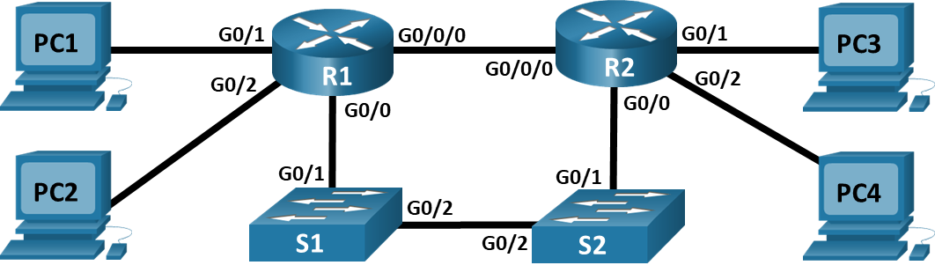

# Addressing Table

| Device | Interface | IP Address / Prefix | Default Gateway |
| --- | --- | --- | --- |
| R1 | G0/0/0 | 192.168.0.1/28 | N/A |
| R1 | G0/0/0 | 2001:db8:acad::1/64 | N/A |
| R1 | G0/0 | 192.168.0.17/28 | N/A |
| R1 | G0/0 | 2001:db8:acad:16::1/64 | N/A |
| R1 | G0/1 | 172.16.1.1/24 | N/A |
| R1 | G0/1 | 2001:db8:acad:171::1/64 | N/A |
| R1 | G0/2 | 209.165.200.1 /25 | N/A |
| R1 | G0/2 | 2001:db8:acad:209::1/64 | N/A |
| R2 | G0/0/0 | 192.168.0.14/28 | N/A |
| R2 | G0/0/0 | 2001:db8:acad::14/64 | N/A |
| R2 | G0/0 | 192.168.0.30/28 | N/A |
| R2 | G0/0 | 2001:db8:acad:16::2/64 | N/A |
| R2 | G0/1 | 172.16.2.1/24 | N/A |
| R2 | G0/1 | 2001:db8:acad:172::1/64 | N/A |
| R2 | G0/2 | 209.165.200.129/25 | N/A |
| R2 | G0/2 | 2001:db8:acad:210::1/64 | N/A |
| PC1 | NIC | 172.16.1.2 /24 | 172.16.1.1 |
| PC1 | NIC | 2001:db8:acad:171::2/64 | fe80::1 |
| PC2 | NIC | 209.165.200.2/25 | 209.165.200.1 |
| PC2 | NIC | 2001:db8:acad:209::2/64 | fe80::1 |
| PC3 | NIC | 172.16.2.2/24 | 172.16.2.1 |
| PC3 | NIC | 2001:db8:acad:172::2/64 | fe80::2 |
| PC4 | NIC | 209.165.200.130/25 | 209.265.200.129 |
| PC4 | NIC | 2001:db8:acad:210::2/64 | fe80::2 |

Blank Line - no additional information

# Objectives

Part 1: Evaluate Network Operation

Part 2: Gather Information, Create an Action Plan, and Implement Corrections

# Background / Scenario

All the network devices in this Packet Tracer Physical Mode (PTPM) activity have been preconfigured to include intentional errors that are preventing the network from routing as intended. Your task is to evaluate the network, identify, and correct the configuration errors to restore full connectivity. You may find errors with the route statements or with other configurations that impact the accuracy of the route statements.

**Note:** The static routing approach used in this activity is used to assess your ability to configure different types of static routes only. This approach may not reflect networking best practices.

# Instructions

## Evaluate Network Operation

Use the **ping** and/or **traceroute** commands from the router to test the following criteria and record the results.

**Note**: Use the PCs in the wiring closet to gain console access to networking devices in order to explore and change the device configurations.

* Traffic from R1 to the 172.16.2.1 address on R2 uses the next hop 192.168.0.14.
* Traffic from R1 to the 209.165.200.129 address on R2 uses the next hop 192.168.0.30.
* When the G0/0/0 interface on R1 is shut down, traffic from R1 to the 172.16.2.1 address on R2 uses the next hop 192.168.0.30.
* Traffic from R2 to the 2001:db8:acad:171::1 address on R1 uses the next hop 2001:db8:acad::1.
* Traffic from R2 to the 2001:db8:acad:209::1 address on R1 uses the next hop 2001:db8:acad:16::1.
* When the G0/0/0 interface on R2 is shut down, traffic from R2 to the 2001:db8:acad:171::1 address on R1 uses the next hop 2001:db8:acad:16::1.

## Gather Information, Create an Action Plan, and Implement Corrections

* + - 1. For each criterion that is not met, gather information by examining the running configuration and routing tables to develop a hypothesis for what is causing the malfunction.
      2. Create an action plan that you think will fix the issue. Develop a list of all the commands you intend to use to fix the issue, and a list of all the commands you need to revert the configuration, should your action plan fail to correct the issue.
      3. Execute your action plans one at a time for each criterion that fails, and record the fix actions.

Type your answers here.

End of document